
Technical Specification Document
<Please update Document Title under Document Property>

Revision History

Version | Date | Summary of Changes | Author
V1.0.0 | 3/19/2018 | First edition | Tony.yang

Technical Specification Sign-Off Signatory

_________________________  Prepared by Tony.yang  Designation: Application Architect |  | IT Department
_________________________  Reviewed by Xiaofei Wang  Designation: Deputy Technology Director |  | IT Department

Contents
1 Architecture Design 5
1.1 Design Philosophy 5
1.2 Technology Selection 5
1.3 Micro Service Unit and Dependencies 5
1.3.1 Services 5
1.3.2 Dependencies 5
1.4 UI Components 6
1.5 API Design 6
1.6 Publishing Event 7
1.7 Subscribing Event 7
2 Object Design 8
3 Database Design 8
3.1 Database Configuration 8
3.2 ER Diagram 8
4 State Machine Diagram Design 9
4.1 XX Diagram 9
5 Sequence Diagram Design 9
5.1 XX Diagram 9

Architecture Design

Design Philosophy
(place your design idea here if necessary)
IM

Technology Selection
Technology | Reason
reactJS+mobx | UI framework
sockJS | JavaScript library that provides a WebSocket-like object in the browser
springBoot | stand-alone, production-grade Spring based Applications
Gradle | project build tool
Docker | Micro-services container

Micro Service Unit and Dependencies

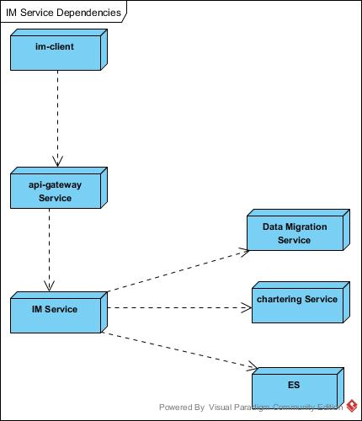

Services
Service | Description
IM-client | user chat tool by React UI Component
IM service | Provide contact ,messages,conversations management api

Dependencies
Dependency | Description
Api-gateway service | manage webscoket & inner services call
Data Migration Service | save&query user chat history messages
Chartering Service | Offer card informations manage

UI Components
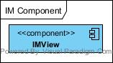

Components | Description
IMView | IM tools

API Design

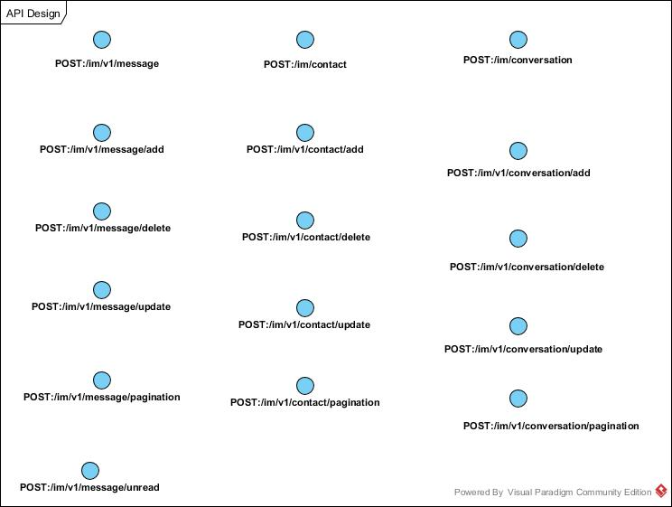

API | Input & Output
POST:/im/login/{userid}  Function:用户登录IM | Input:  {  }  Output:  {  token  }
GET:/im/contact/{userid}  Function:查询用户基本信息 | Input:  {  }  Output:  {  id,  name,  icon,  createTime,  updateTime  }
POST:/im/contact/{userid}/edit  Function:修改用户基本信息 | Input:  {  _method:"put",  name: [mandatory, string,length[1-60],  icon: [mandatory, string,length[1-300]  }  Output:  {  }
GET:/im/contact/relation/{userid}  Function:查询用户的联系人列表 | Input:  {  }  Output:  {  [  {  id,  name,  icon,  createTime,  updateTime  }  ]  }
POST:/im/contact/relation/{userid}  Function:添加联系人 | Input:  {  friendId: [mandatory, bigint]  }  Output:  {  }
POST:/im/contact/relation/{userid}/del  Function:删除联系人 | Input:  {  friendId: [mandatory, bigint]  }  Output:  {  }
POST:/im/conversation  Function:创建新的会话 | Input:  {  friendId: [mandatory, bigint],  curUserId: [mandatory, bigint]  }  Output:  {  }
POST:/im/conversation/{id}/edit  Function:修改会话基础信息 | Input:  {  name: [mandatory, string,length[1-60],  icon: [mandatory, string,length[1-300]  }  Output:  {  }
POST:/im/conversation/relation/{conversationId}  Function:邀请联系人加入会话 | Input:  {  friendId: [mandatory, bigint],  curUserId: [mandatory, bigint]  }  Output:  {  }
POST:/im/conversation/relation/{conversationId}/del  Function:用户退出会话 | Input:  {  friendId: [mandatory, bigint],  curUserId: [mandatory, bigint]  }  Output:  {  }
POST:/im/message  Function:发送消息 | Input:  {  conversationId: [mandatory, bigint],  curUserId: [mandatory, bigint],  typeId: [mandatory, tinyint],  content: [mandatory, string,length[1-768]  }  Output:  {  }
GET:/im/message/list  Function:分页获取会话消息 | Input:  {  conversationId: [mandatory, bigint],  startMessageId: [mandatory, int]  pageSize: [mandatory, int]  }  Output:  [{  messageId,  conversationId,  sender,  type,  content,  sendTime  }]
GET:/im/conversation/list  Function:登录后获取会话列表 | Input:  {  curUserId: [mandatory, bigint]  }  Output:  [{  conversation:{  id,  name,  icon,  status,  createTime,  updateTime  },  users:[  {  id,  name,  icon,  createTime,  updateTime  }  ]  messages:[  {  messageId,  conversationId,  sender,  type,  content,  sendTime  }  ],  unreadSum  }]

Publishing Event
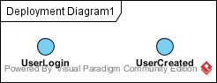

Event | Parameter
UserLogin | {  result: [“OK”, “ERR”],  token: [string, nullable],  user: [object: User, mandatory]  }
UserCreated | {  user: [object: User, mandatory]  }

Subscribing Event
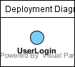

Event | Parameter
UserLogin | {  result: [“OK”, “ERR”],  token: [string, nullable],  user: [object: User, mandatory]  }

Object Design

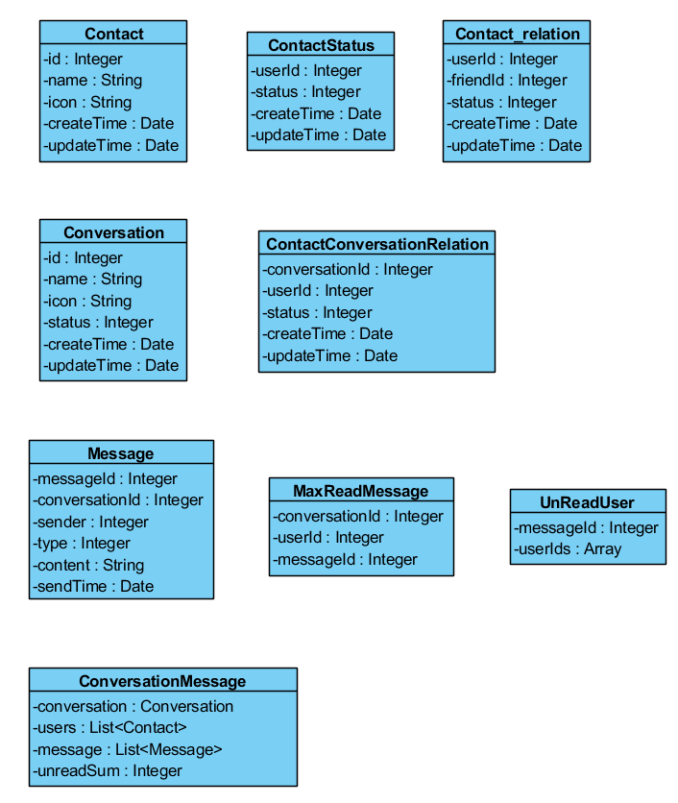

Contact
Property | Data Type | Data Constraints
id | Integer
name | String
icon | String
createTime | Date
updateTime | Date

ContactRelation
Property | Data Type | Data Constraints
userId | Integer
friendId | Integer
status | Integer
createTime | Date
updateTime | Date

ContactStatus
Property | Data Type | Data Constraints
userId | Integer
status | Integer
createTime | Date
updateTime | Date

Conversation
Property | Data Type | Data Constraints
id | Integer
name | String
icon | String
status | Integer
createTime | Date
updateTime | Date

ContactConversationRelation
Property | Data Type | Data Constraints
ConversationId | String
userId | String
Status | Integer
createTime | Date
updateTime | Date

Message
Property | Data Type | Data Constraints
messageId | Integer
sender | Integer
recieverIds | Array
type | Integer
content | String
sendTime | Date

UnReadUsers
Property | Data Type | Data Constraints
messageId | Integer
userIds | Array

MaxReadMessage
Property | Data Type | Data Constraints
conversationId | Integer
userId | Integer
messageId | Integer

ConversationMessage
Property | Data Type | Data Constraints
conversation | Conversation
users | List<Contact>
messages | List<Message>
unreadSum | Integer

Database Design

Database Configuration
Configuration | Value | Remark
Database Name | im
User Name | bwim
Password | bwim | For developer only
Default Charset | utf8mb4 | To support emoji
Dev DB Host | 192.168.1.1:3306
SIT DB Host | 192.168.11.1:3306
UAT DB Host | 192.168.111.1:3306
ID generator | Remote ID service

ER Diagram

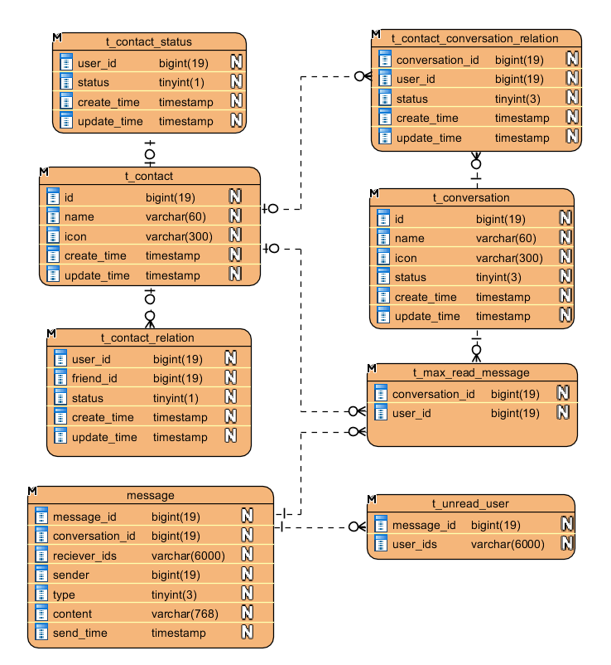

Cache Design
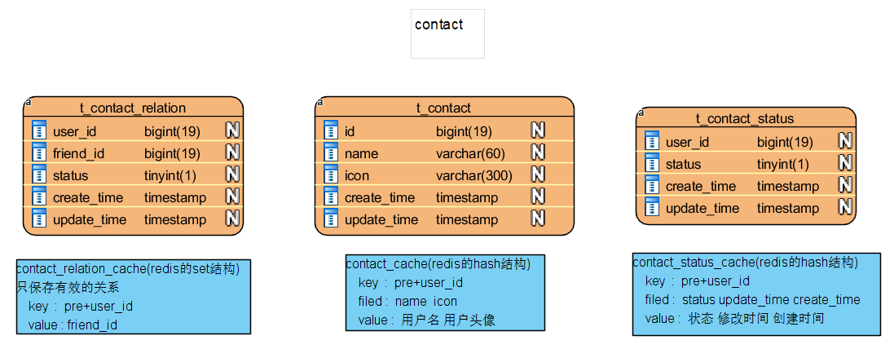

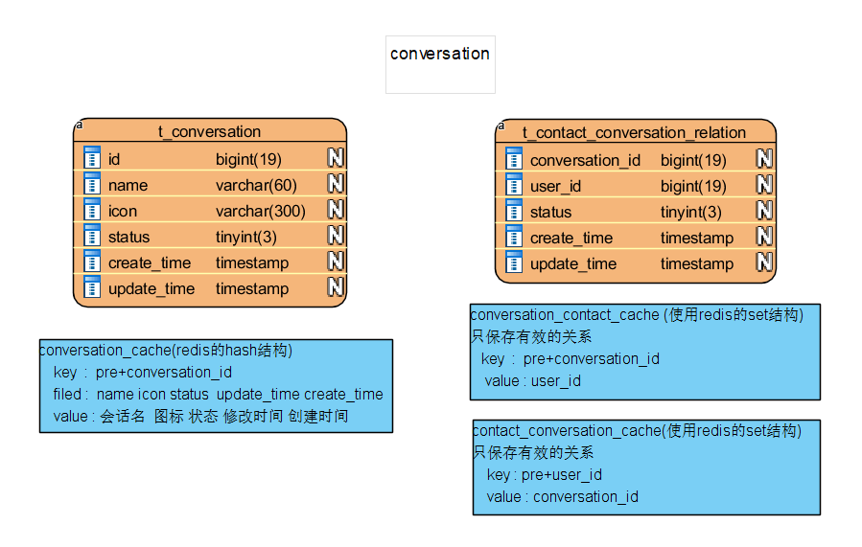

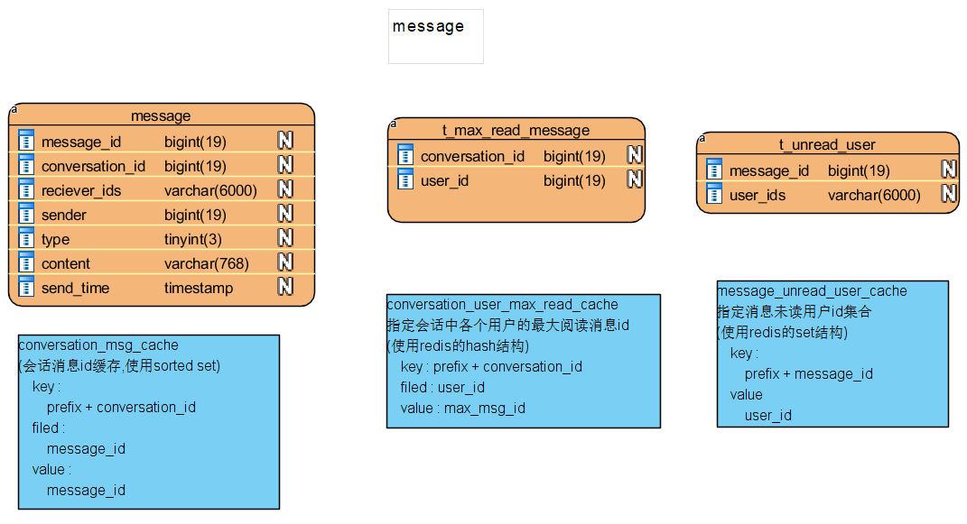

Sequence Diagram Design
(place design diagram here if necessary)

Connation API-GW Diagram
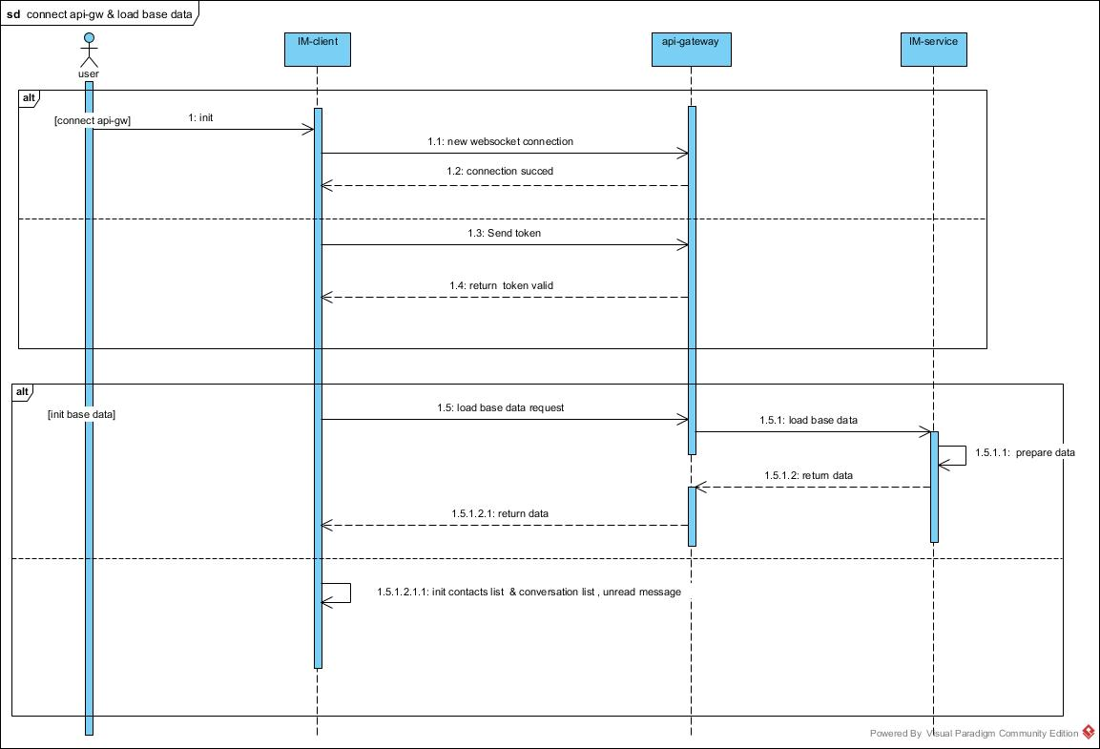

Push message Diagram
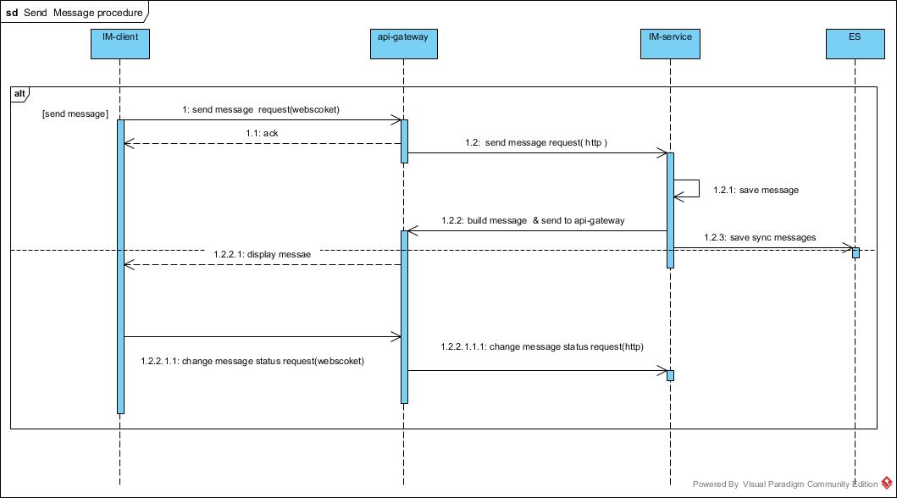

Pull unread message Diagram
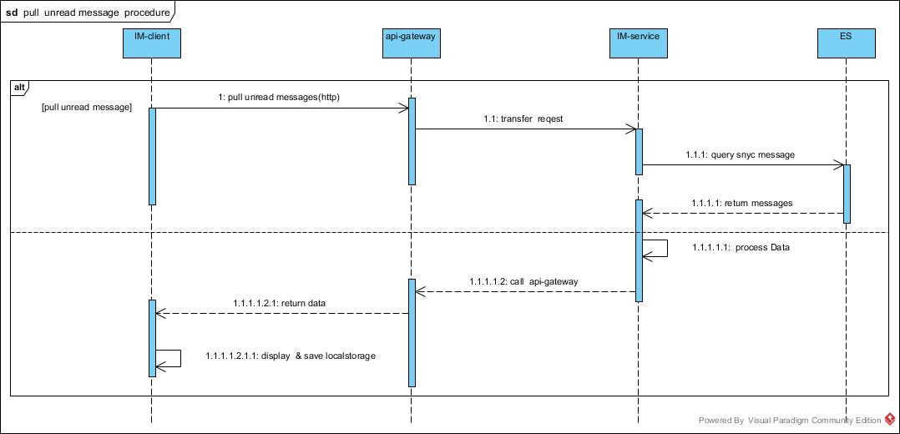

Pull history message Diagram
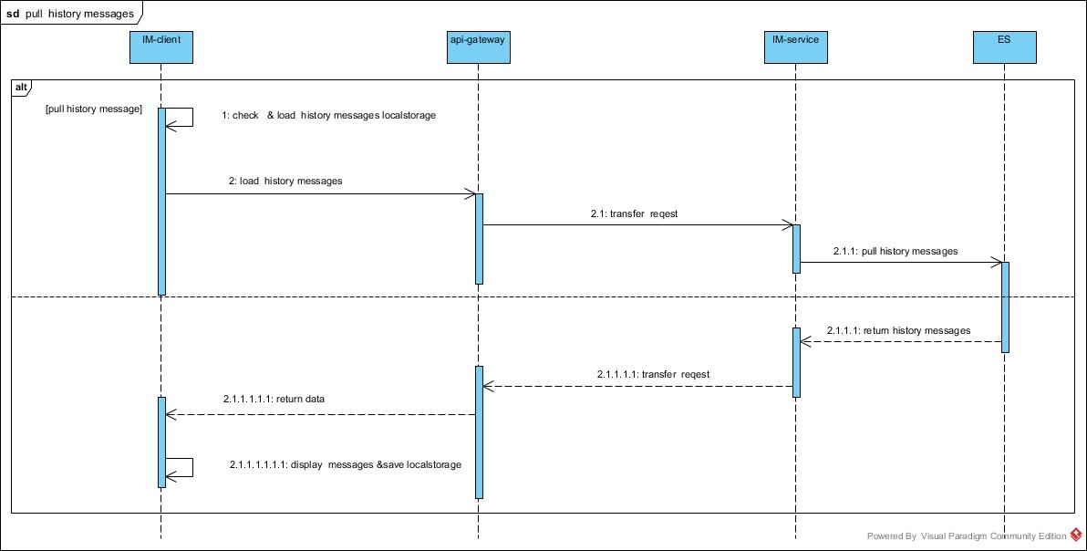

Sync user status Diagram
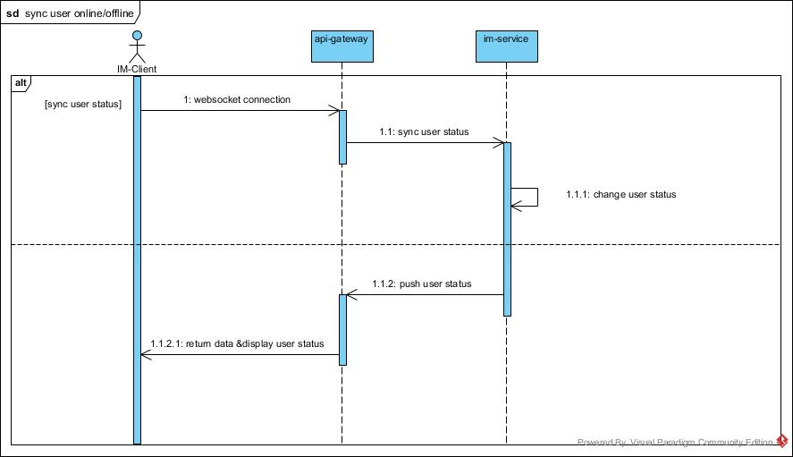

Sync message status Diagram
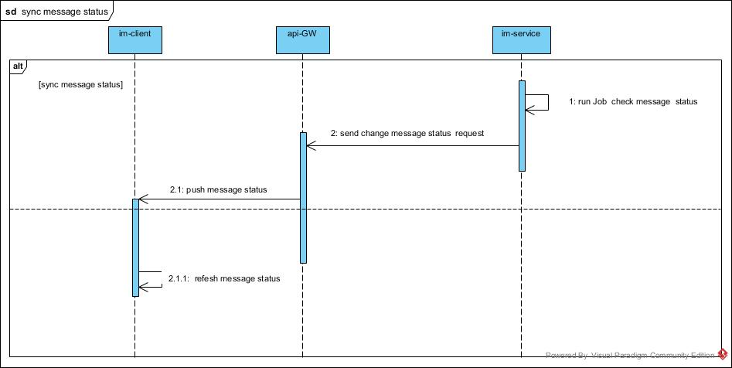

IM Components Details
IM components split details

IM Component Design
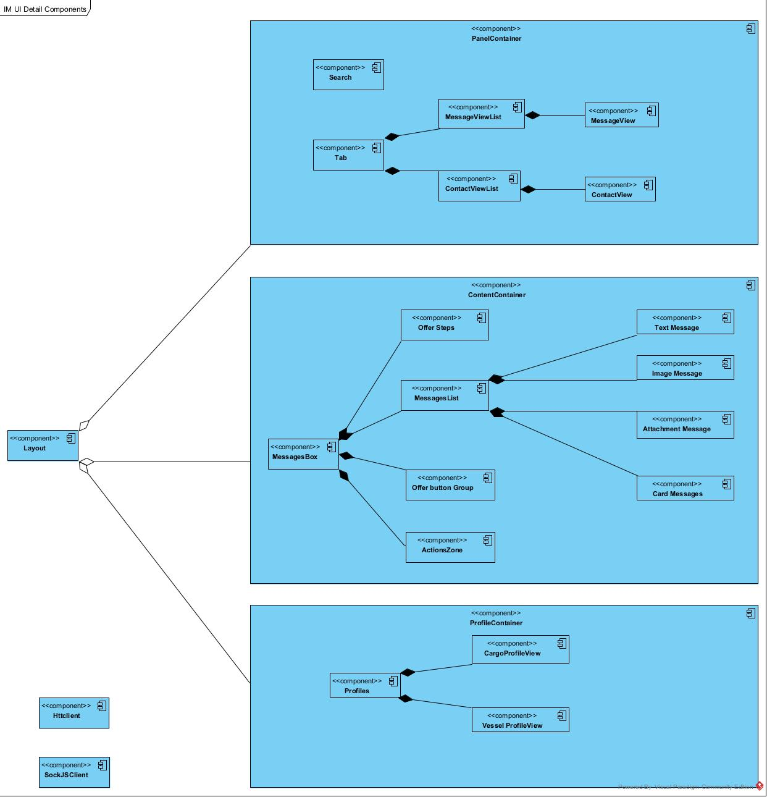

IM System Structure
